Before getting started the website we needed to test the website in many cases and the whole website design testing tools is bellow and I have explain all the testing sections part by part for the website design for this website. I’ll use the following toolkit to complete the testing process:

1. [**www.asana.com**](http://www.asana.com)**:** This tools is Used for bug-tracking and team management. This website is 100% bug free and we use this tool for team management.
2. **Website Speed:** We use <https://gtmetrix.com> for website speed test. Report’s are mentioned bellow:

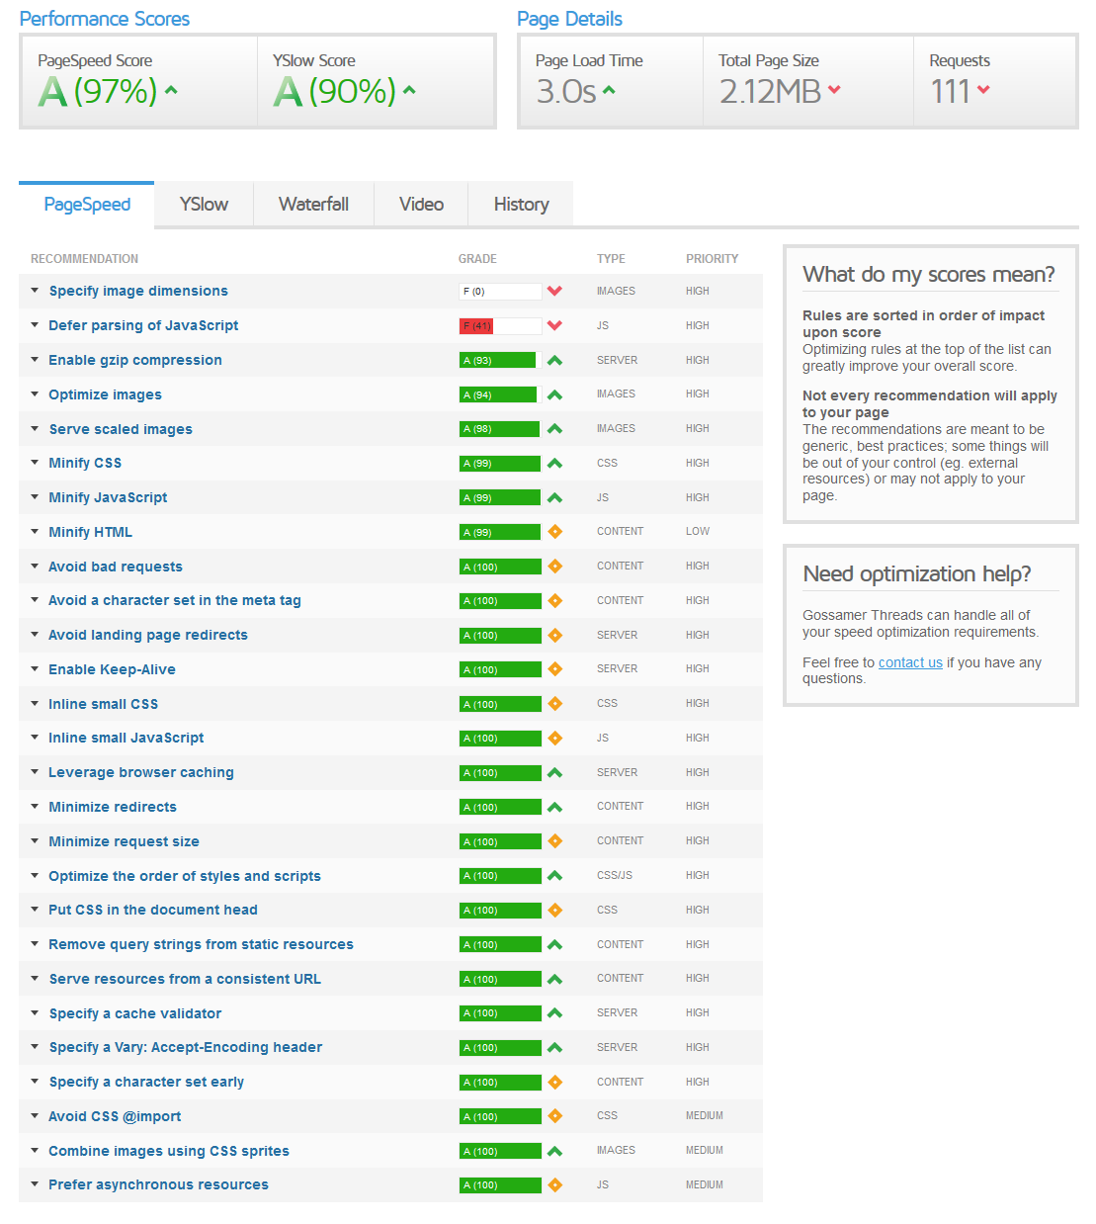

1. [**Chrome Developer Tools**](https://developer.chrome.com/devtools)**:** we use chrome developer tool for Used for inspecting, debugging and profiling.
2. **Devices:** Ideally, you’ll want real devices. We have iPhone 4, 5 and 6; HTC One M8; Samsung Galaxy S5; Nokia Lumia 1520; Google Nexus 5; BlackBerry Curve; iPad 2; and Asus VivoTab Smart. If you don’t have these, you can use BrowserStack’s emulators.